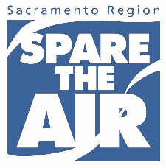

**Frequently Asked Questions**

**1. What is Spare The Air?**

Spare The Air is the Sacramento region’s summer campaign, coordinated by the Sac Metro Air District, on behalf of the air districts of the region. The campaign informs people about the dangerous health effects of air pollution and asks residents to drive less to reduce pollution when a Spare The Air alert is issued.

**2. When is a Spare The Air alert issued?**

A Spare The Air alert is issued during peak ozone months, May 1 – October 31, when ground-level ozone (smog) is forecast to meet or exceed 126 on the Air Quality Index (AQI).

**3. What is the Air Quality Index?**

The Air Quality Index (AQI) was developed by the U.S. Environmental Protection Agency. It’s used nationwide to help you understand what local air quality means to your health. The higher the AQI value, the greater the amount of air pollution, which means the greater the health concerns. The AQI is a great tool for you to use to determine if you can enjoy the outdoors as usual, or if you should consider planning an indoor activity to reduce exposure to air pollution.

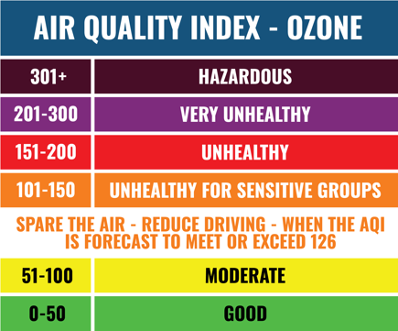

**4. What are the health effects of air pollution?**

Anyone – even healthy people – can experience health impacts from air pollution, including respiratory irritation or breathing difficulties during exercise or outdoor activities. Your actual risk of adverse effects depends on your current health status, the pollutant type and concentration, and the length of your exposure.

High air pollution levels can cause immediate health problems, including:

* Aggravated cardiovascular and respiratory illness
* Added stress to heart and lungs, which must work harder to supply the body with oxygen
* Damaged cells in the respiratory system

Long-term exposure to polluted air can have permanent health effects, such as:

* Accelerated aging of the lungs
* Loss of lung capacity and decreased lung function
* Development of diseases such as asthma, bronchitis, emphysema, and possibly cancer
* Shortened life span

**5. Who is most vulnerable to poor air quality?**

Those most susceptible to health problems from air pollution are:

* Children
* Older adults and the elderly
* Individuals with heart disease, coronary artery disease or congestive heart failure
* Individuals with pulmonary or respiratory diseases, including congestive heart failure and asthma
* Pregnant women
* Outdoor athletes and workers

People in these groups may experience health impacts at lower air pollution levels, or feel health effects more severely at any level.

**6. How can air pollution impact you?**

* Aggravate respiratory diseases such as emphysema, bronchitis and asthma
* Cause lung damage, even after symptoms such as coughing or a sore throat disappear
* Cause wheezing, chest pain, dry throat, headache or nausea
* Reduce resistance to infections
* Increase fatigue
* Weaken athletic performance

**7. What are some ways to improve air quality?**

1. Drive less to help reduce vehicle emissions, especially on a Spare The Air day
2. Telework at least once per week, if possible
3. Take public transit to reduce the number of single-passenger vehicles on the road
4. Use a zero emission or alternative transportation option, including hybrid or electric vehicles, walking, biking, or riding a scooter
5. Bring your lunch to work
6. Use a propane grill
7. Use an electric lawn mower, electric-power tools and other electric lawn/garden equipment
8. Refuel after the sun goes down
9. Don’t idle – turn off your engine when parked
10. Visit our “[Things To Do](http://www.sparetheair.com/takeAction/index.cfm)” page on SpareTheAir.com for a complete list

**8. How can I receive Spare The Air alerts?**

* Download the **FREE Sacramento Region Air Quality app,** available in all app stores, including iPad
* Follow on **Twitter @AQMD**
* Visit [**www.SpareTheAir.com**](http://www.AirQuality.org)
* Sign up to get daily Air Alert emails at [www.SpareTheAir.com](http://www.SpareTheAir.com)

**9. Where can I get more information?**

Contact the Sac Metro Air District at **1-800-880-9025,** or visit **www.SpareTheAir.com.**